4 Letter Words Final
Reflection
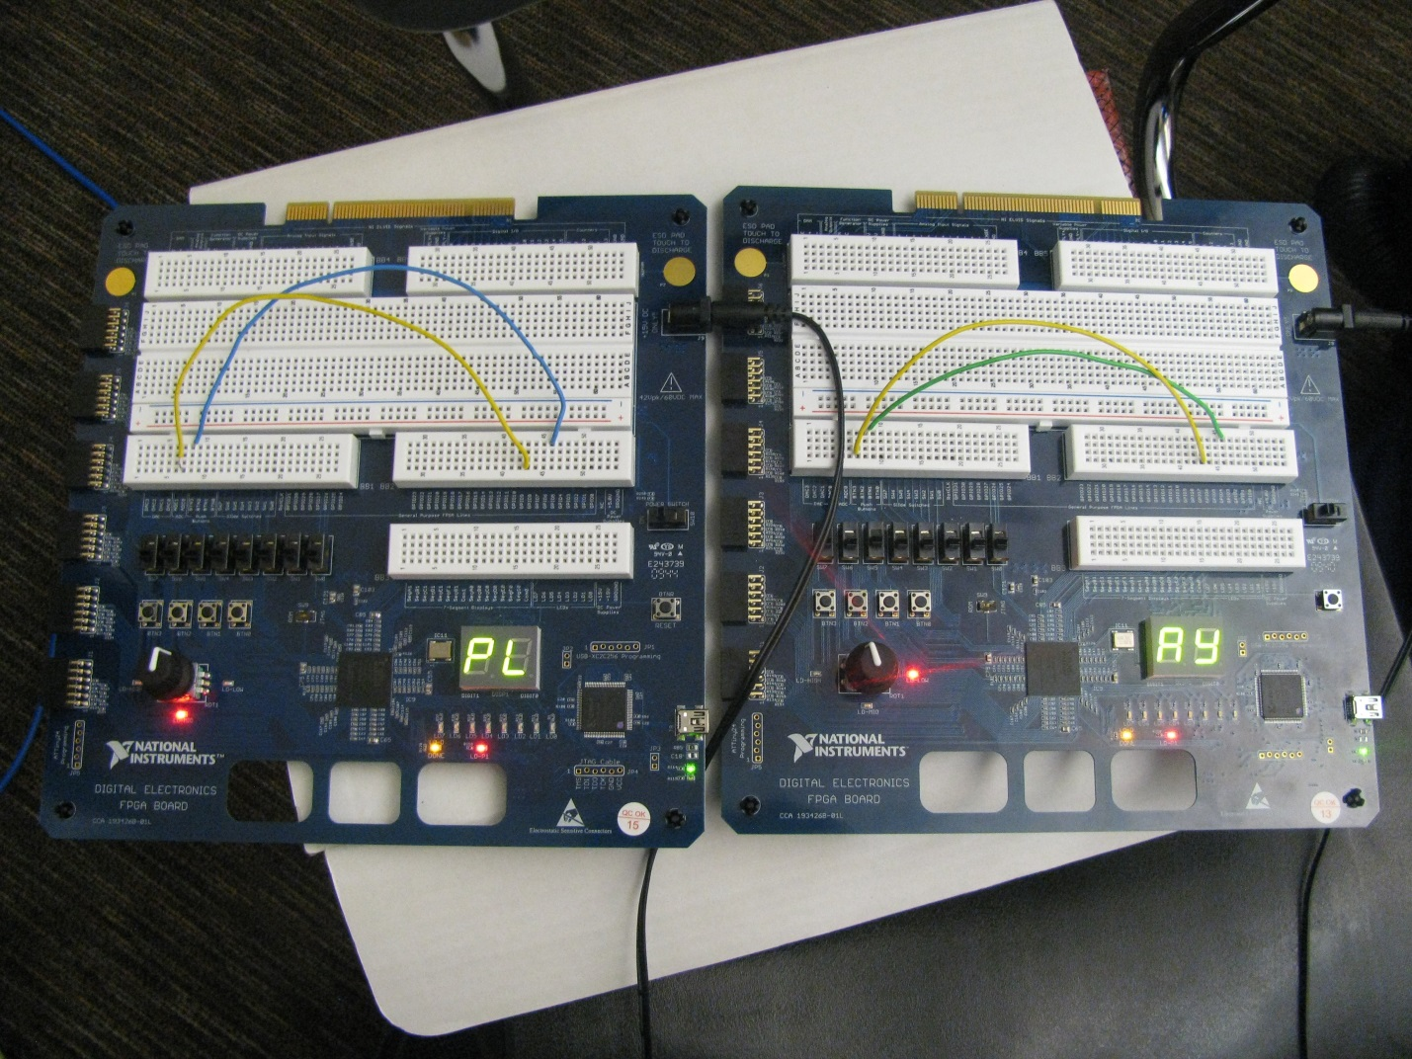
By
Andres Correa
Luis Hernandez
Nick Hammond
25 May 2013
Digital Electronics 1B
Mr. Wemp
The 4 Letter Words Final was a very creative, learning experience for my team. We followed the design process and got a very desirable final product, but it took a lot of work. We first started out by throwing out many ideas into each other’s eardrums. Many creative ideas were discussed, and after we had thrown out all of our ideas, each one of the team members sketched their final thoughts into their own possible project idea, and then were all placed on the brainstorming pages. The "Arcade" sketch was from Nick and he proposed a series of letters to be moved around in a screen, just like you do when you have gotten a high score on Galaga or Pac-Man. Luis's "Random Counter" was going to be a display which would simulate the rolling of a dice, and display a random number every time a button was pushed. Lastly, the "4-Letter Self" and the "4-Letter Team" ideas were all, essentially, the same design (just different concept), from me, and they dealt with having four switches, each connected to a single display drive, which would show you letters and you would have to spell out words. I had gotten this idea from the new knowledge I had gained from doing the MSI Synchronous Counters design, a while back, and all of the troubleshooting I did with the Common-Cathode 7-Segment Display, on that counter design. All of these were good ideas, but we decided on the 4-Letter idea. We then jotted down all of the letters possible (and most used in the English dictionary) that could be displayed using only a Common-Cathode 7-Segment Display.
The 4 Letter Words Final design incorporates many of the past design concepts, and techniques, learned throughout the entire Digital Electronics class. After we go to the conclusion to design and build the 4 Letter Words Final, we had to come up with a way to incorporate this into a game that would be more suited for college students who would not only be in the Digital Electronics class, but also might go into a future engineering career. The original design was just to have four switches, on one breadboard, which each switch would control a single 7-Segment Display, and one person would come up with all the four letter words. Upon further brainstorming, on how we could further the implementation of this idea onto a game, the idea of two people playing together as a team in order to see how many four letter words they could make, in a certain amount of time, was what we chose to be the best game in which digital electronic and engineering concepts could both be shown.
After we had decided what we were going to do, we started laying out the possibilities on how we could accomplish this idea the most efficient way, and still use as much digital electronics concepts as we could. We decided to incorporate the Date of Birth Design concepts, along with concepts from Now Serving Display, in order to accomplish the desired design. The Date of Birth Design problem was exactly what we needed to know, in order to accomplish the 4 Letter Words Final design. In the Date of Birth Design, we took three inputs and made them count in binary. Since we have three inputs, the number of possible outputs is 2³, or 8. These eight outputs would represent a digit in your birthday (mm-dd-yy, including hyphens), when the inputs were switched to count in binary. Every count was going to display a digit, which would light up certain segments on the 7-Segment Display.
The 4 Letter Words Final truth table was constructed the same way in which the Date of Birth truth table was. When doing the truth table for the 4 Letter Words Final design, we first needed to see how many inputs we were going to have. We could have easily chosen 5 inputs so we could incorporate all 26 letters of the English alphabet (giving us 2 ⁵, or 32 outputs) but there are two problems with this idea. First of all, not all of the letters in the English alphabet can be displayed (only 21 letters can be displayed) using a Common-Cathode 7-Segment Display, so we would have many outputs that did “nothing” in the design. Secondly, we ultimately wanted only one switch, not 3, 4, or 5 switches, to make the letters change. This is where the synchronous counter, from the Now Serving Display concepts, comes into play. By having that one switch be the clock for our Synchronous Binary Up/Down Counter (74LS193N gate), we could create an output that read in binary. Every time you turned on and off the switch, this would create a count, which read in binary. Using this counter though would limit our binary outputs to only 16, since there were only 4 pins (A, B, C, and D). We took these four outputs from the Synchronous Binary Up/Down Counter (74LS193N gate), and used them as our inputs for our 4 Letter Words Display. Every output (or count, in binary) would be assigned one letter, or minterm, which the 16 most common used letters in the English alphabet were used. Each count from 0-15 would represent one of the chosen letters from the alphabet, in order, which would light up different segments on the 7-Segment Display. We used Karnaugh mapping techniques in order to see when every segment would be in use, according to the binary count.
The design worked perfectly on Multisim, our circuit-design software The Boolean expression was then obtained, and simplified, and we were ready to start simulating the design. We placed a switch onto the Synchronous Binary Up/Down Counter (74LS193N gate), and then attached that the counters outputs to our combinational logic design (the first four segments consist of AOI logic, while the last three are implemented with NAND logic), in which every output went to a Common Cathode 7-Segment Display, through 220 Ω resistors. We also added a reset switch, attached to the CLR pin on the counter gate, in case you passed a letter certain letter, so that you would not have to go through all the remaining outputs before the count came back to the beginning. Whenever the reset switch is “on”, the count resets at 0, displaying an “A” on the 7-Segment display. If you flip your count switch, while the reset switch is “on”, or flipped, nothing happens, but if you “turn off” the reset switch (just flip the switch back), the count will begin at 0 (or A) and now you are able to flip your count switch and display letters. This would enhance the ability to display a larger amount of words, in a given period of time.
We then converted out design, using programmable logic, so that we could simulate our final product design, in real-life, using the Digital Logic Boards. We ran into a few problems when our logic board would sometimes not show us any letters in the integrated 7-Segment Display, or it would jump letters if it did show us any. This was resolved with more concepts learned from the Now Serving Display problem. In the Now Serving Display problem, we had to transfer a design which used the Synchronous Binary Up/Down Counter (74LS193N gate), onto the Digital Logic Boards. We learned that an input wired to a clock has to go through specific pins on the Digital Logic Boards. There were specific pins which if the clock input, on the gate, was not wired to, the whole design would not work. GPIO8 and GPIO5 were the best candidates to wire our switch, or in this case a button, while using the Digital Logic Boards. We also learned that the display would sometimes “jump” counts or letters on the display. This would be solved by adding a D-Flip-Flop to the design, in between the input button and the clock to the counter. The Flip-Flop works best when simulated in its actual design (i.e. using the NAND circuit design, inside of the Flip-Flop), and a switch was used to clear or “reset” the design, when we used the Digital Logic Boards.
We troubleshooted the digital logic boards for at least 5 hours. This was truly a learning experience, in which new knowledge was gained. I appreciate it when I get to learn something new, when looking back at a design, which seemed straightforward, and all of its possibilities exhausted, because that is what engineering is all about. My team and I got to use many techniques that we learned during this course, which we executed flawlessly. We not only learned, but improved our techniques and concept understanding, by the end of the final design.

